Working in the Cloud

with ClearMedia Academy

ClearMedia vCloud Director template 1.5

**Disclaimer**:

By using the ClearMedia vCloud Director templates, you can greatly reduce the amount of time needed to deploy new VMs. These templates have been configured with the best practices in mind, to assure optimal stability and performance. Although use of the template is not compulsory, it is recommended!

On this first page you can find a small overview of the required steps. It is intended for engineers that already have experience with the ClearMedia vCloud Director and previous ClearMedia templates. The larger, more in-depth explanation with screenshots, can be found further on. It can be used by people without any prior knowledge if the overview is not clear or if it has been a while since your last deployment.

You can deploy the template from 3 different places. We use the first option in this document.

1. from the Public Catalog.
2. from the “Home” or “My Cloud” tab (new vApp).
3. from the vApp overview (Adding extra VMs to an existing vApp).

Quick steps

This guide assumes you are building a new vApp and deploying the template from the “Catalog” tab with a single server setup. Connecting the new vApp to the internet is covered in the later documents.

* Do not use the steps below if you do not know how to start with the first step. Go to the In-Depth explanation instead.
* Select the tab “vApp Templates, right-click on the “Win2016 Version 1.5” template and choose “Add to My Cloud”.
* Run through the first step of the wizard, give the new vApp a name and click “Finish”
* Check the Boot Properties of the newly created vApp by right-clicking on the new vApp in the overview and then at the bottom on “Properties”. Save the changes and open the vApp.
* Edit the VM properties and set a strong password under Guest Customization.
* Run the VM for 10 minutes, power it off and disable all Guest Customization options.
* Start the VM back up and wait at least 15 minutes for burn-in time.
* Finished!

In-Depth explanation and step-by-step procedures

* Ask ClearMedia for extra resources via ticket, referring to a newly created quote.
* Check if you have enough resources via the “Administration” tab, under subtab “Monitor”.
* Contact ClearMedia if there are not enough resources.

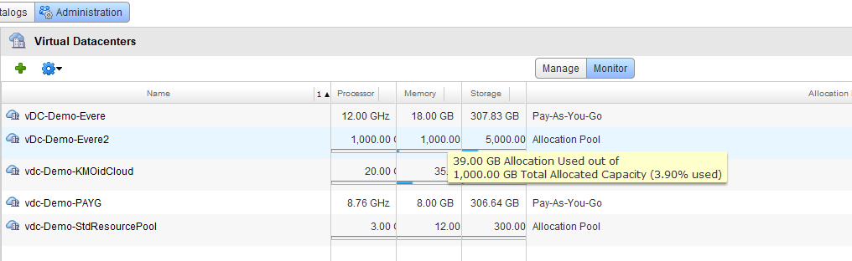

* Go to the Catalogs tab and navigate to the “vApp Templates” tab of the “Public Catalogs”.

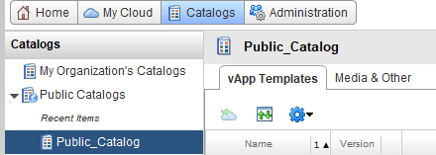

* On the right side, under “Customize Columns”, check the box for “Description” to see extra information about the templates.

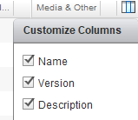

* Right-click on the “Win2016 Version 1.5” template and choose “Add to My Cloud”.

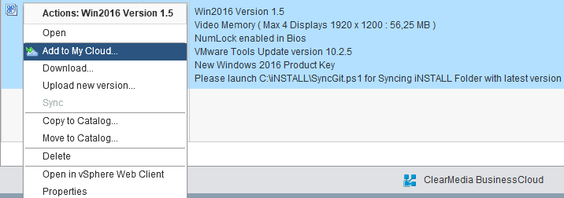

* Run through the steps of the wizard: (vApp name, description, location, storage, network).
* Use the end customer name as used in the contract, preceded by “vApp_”.
* Select the VDC, based on available resources (see step 2). If you do not have enough resources, please Contact ClearMedia Support.
* You do not need to change anything on the other tabs. Just click on “Finish” to deploy the template. We will edit the rest later.

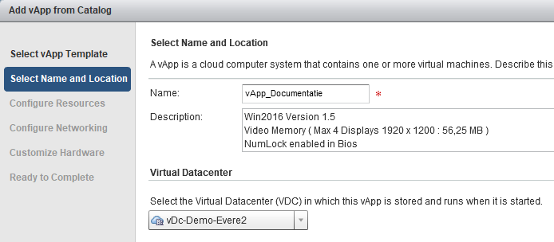

* Go to “My Cloud”. You can see the progress of the deployment here

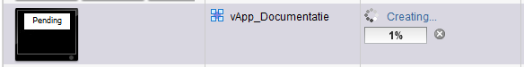

* It will take at least 20 minutes per VM to deploy.
* Check the Boot Properties of the newly created vApp by right-clicking on the new vApp in the Home or My Cloud overview and then at the bottom on “Properties”.



* On the “Starting and stopping VM’s” tab, check boot order and “Stop Action” for each VM
* For a Windows Server, this should be “Shut Down”, for firewall appliances it should be “Power off”. Save the changes and open the vApp.

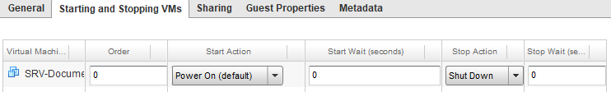

* Now edit the new VM. Right click on it and at the bottom, click on Properties
  + On the “General tab”, change the Virtual Machine name and Computer name starting with “SRV-“
  + Do not change the Operating System tag! **Never use** “Server 2016” as the OS type, since **this does not work**!
  + Note that the tick boxes “Virtual CPU Hot add” and “Memory Hot add” are enabled.

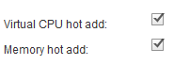

* + On the “Hardware tab”, type in the desired resources. You are not limited to the dropdown menu choices for Disk or RAM. However, if you need more then 200GB of disk space, you must add this 200GB per hour or contact ClearMedia.
  + At the network adapters, check the option “Show network adapter type” and verify you are using a “VMXNET 3” adapter with Windows VM.

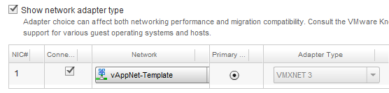

* + On the “Guest OS Customisation” tab, choose a complex password with a minimum 7 characters, 1 special character, and 1 number. Otherwise Windows will not accept it during Guest Customisation and logging on to the system will fail.
* Power on the VM by right clicking, and pressing “Start”. If this is the first time, wait at least 5 minutes for powering on and guest customisation to run successfully. It should finish with an automatic reboot.
* Open the Virtual Machine console based on the “How-To VM Console” document.
* Logon with the new administrator credentials and verify that Guest Customisation ran successful.
* The VM will ask if it is allowed to be discovered on the network. This is personal preference.
* Then turn the VM off again using the big red square button



* Disable all Guest Customisation options, starting from the bottom. Start with the “password reset” tick box. Then the “Change SID” tick box. Finish with the “Enable Guest Customisation” box.

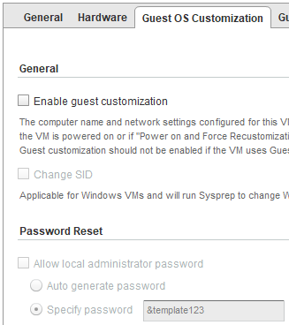

* After disabling all Guest Customisation options leave the VM off and also stop the entire vApp.
* Now add an internet connection via a vShield Edge or WatchGuard FireboxV. You can find the procedures in the next documents (How-To 2 vShield Edge & How-To 3 Watchguard FireboxV).
* **Finished!**